Name: ____________________________________________ Period: _______ Date: ______________

**Systems of Linear Equations Applications Practice**

1. The sophomore class is planning a field trip. The class can either visit the natural science museum or a United States history museum. At the natural science museum, tickets cost $24 each, plus a flat rate of $47 for parking all the buses. At the United States history museum, tickets cost $15 each, plus a flat rate of $85 for parking all the buses.  
  
Let *x* represent the number of people going on the field trip, and let *y* represent the total cost of the field trip. Write a system of equations that could be used to find how many people can go on either field trip so that both field trips have the same cost?

2. Planet Fitness offers a silver membership and a gold membership. The table contains information about the one-time registration fee and monthly fee for each membership.

|  |  |  |
| --- | --- | --- |
| Membership | Registration Fee | Monthly Fee |
| Silver | $0 | $105 |
| Gold | $650 | $55 |

In how many months would the gold membership be a better value than the silver membership?

3. A water company offers industrial users two different packages. The users can either pay 50 cents per thousand gallons or pay a fixed amount of $975,000 for unlimited water usage for one year. How much water does an industrial user need to use in one year for the fixed amount package to be the less expensive option?

4. Bradley has hired a construction crew to renovate his bathroom. They charge $4.55 per square foot for materials and $135.10 per day of labor. Bradley spent $6,239.45 on the renovation. If the number of square feet is 205 more than the number of days it took for the renovation, how long did the renovation take?

5. Ella is cooking a turkey and a ham. It takes 12 minutes per pound to cook a turkey and 21 minutes per pound to cook a ham.  
  
Ella can cook the turkey and the ham in 6 hours and 39 minutes. If the turkey weighs three times as much as the ham, how much do the turkey and the ham weigh?

6. The equations representing income and expenses for Tom's candy store are shown in the graph below.

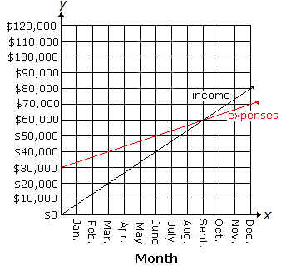

Let *x* represent the month and *y* represent the amount in dollars. In which month were the store's expenses greater than its income?

7. A chemist currently has a solution of 25% hydrochloric acid and a solution of 10% hydrochloric acid. He mixes the two solutions together to create 30 ounces of a 20% hydrochloric acid solution. How many ounces of the 25% hydrochloric acid solution did he use in order to obtain the 20% solution?

8. Paul is looking at two vacation packages while planning a trip to Cancun, Mexico. In the first vacation package, round-trip airfare costs $359, and it costs $197 per night to stay at the resort. In the second vacation package, it costs $654 per night to stay in the resort and $297 for round-trip airfare.  
  
Let *x* represent the number of nights spent at the resort, and let *y* represent the total cost of the trip. Write a system of equations that could be used to find how many nights Paul needs to stay at either resort so that both vacation packages have the same cost?

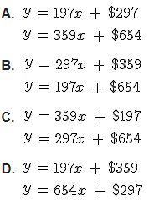

9. Cristobal is comparing the membership club fees at two different bookstores. At the first bookstore, it costs $15.77 annually to be a member of the club, but he will save 15% on all his purchases. At the second bookstore, it costs $26.09 annually to be a member of the club, but he will save 25% on all his purchases.  
  
How much does Cristobal need to spend in a year for the membership at the second bookstore to be the better value?

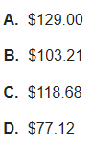

10. Sydney needs to earn $35 so she can buy her father a birthday present. Her mom said she can make $6 per hour cleaning around the house and $5 per hour raking leaves. There are 6 hours available before Sydney's father's birthday party where she can either clean or rake leaves.  
  
Which system of equations can be used to find how many hours Sydney should spend cleaning and raking leaves so that she will earn exactly enough money to buy her father a birthday present? Let *x* represent the number of hours spent cleaning and *y* represent the number of hours spent raking leaves.

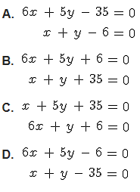

11. A grocery store is offering a promotion where a customer receives a $0.15 discount per item on selected sale items, and Paulo has a coupon where he receives $0.10 off regularly priced items.  
  
Before applying the discounts, the cost of Paulo's sale items was $55.30 and the cost of Paulo's regularly priced items was $43.60. After applying the discounts, Paulo spent $92.50 on both the sale items and regularly priced items.  
  
If Paulo bought 11 more sale items than regular items, how many items did he buy in all?



12. Henry takes guitar and piano lessons. Last month, he went to 3 guitar lessons and 4 piano lessons for a total cost of $195. This month Henry went to 4 guitar lessons and 2 piano lessons for a total cost of $160.

The following system of equations can be used to determine the cost of each type of lesson.



The cost of each guitar lesson is represented by x. The cost of each piano lesson is represented by y. How much is a guitar lesson?

